
__________________________________________________________________________________

GROUP 5 TERM PROJECT- PHASE III
FUNDAMENTALS OF DATA ENGINEERING (MSDA-3040)
Submitted By:
Anurag Joshi
Varsha Butta
Sai Divya Veerepally
Isaack Nyagweso
Sai Harshith Reddy Gaddamidhi

Question 1 - Dashboard should have 3+ graphs

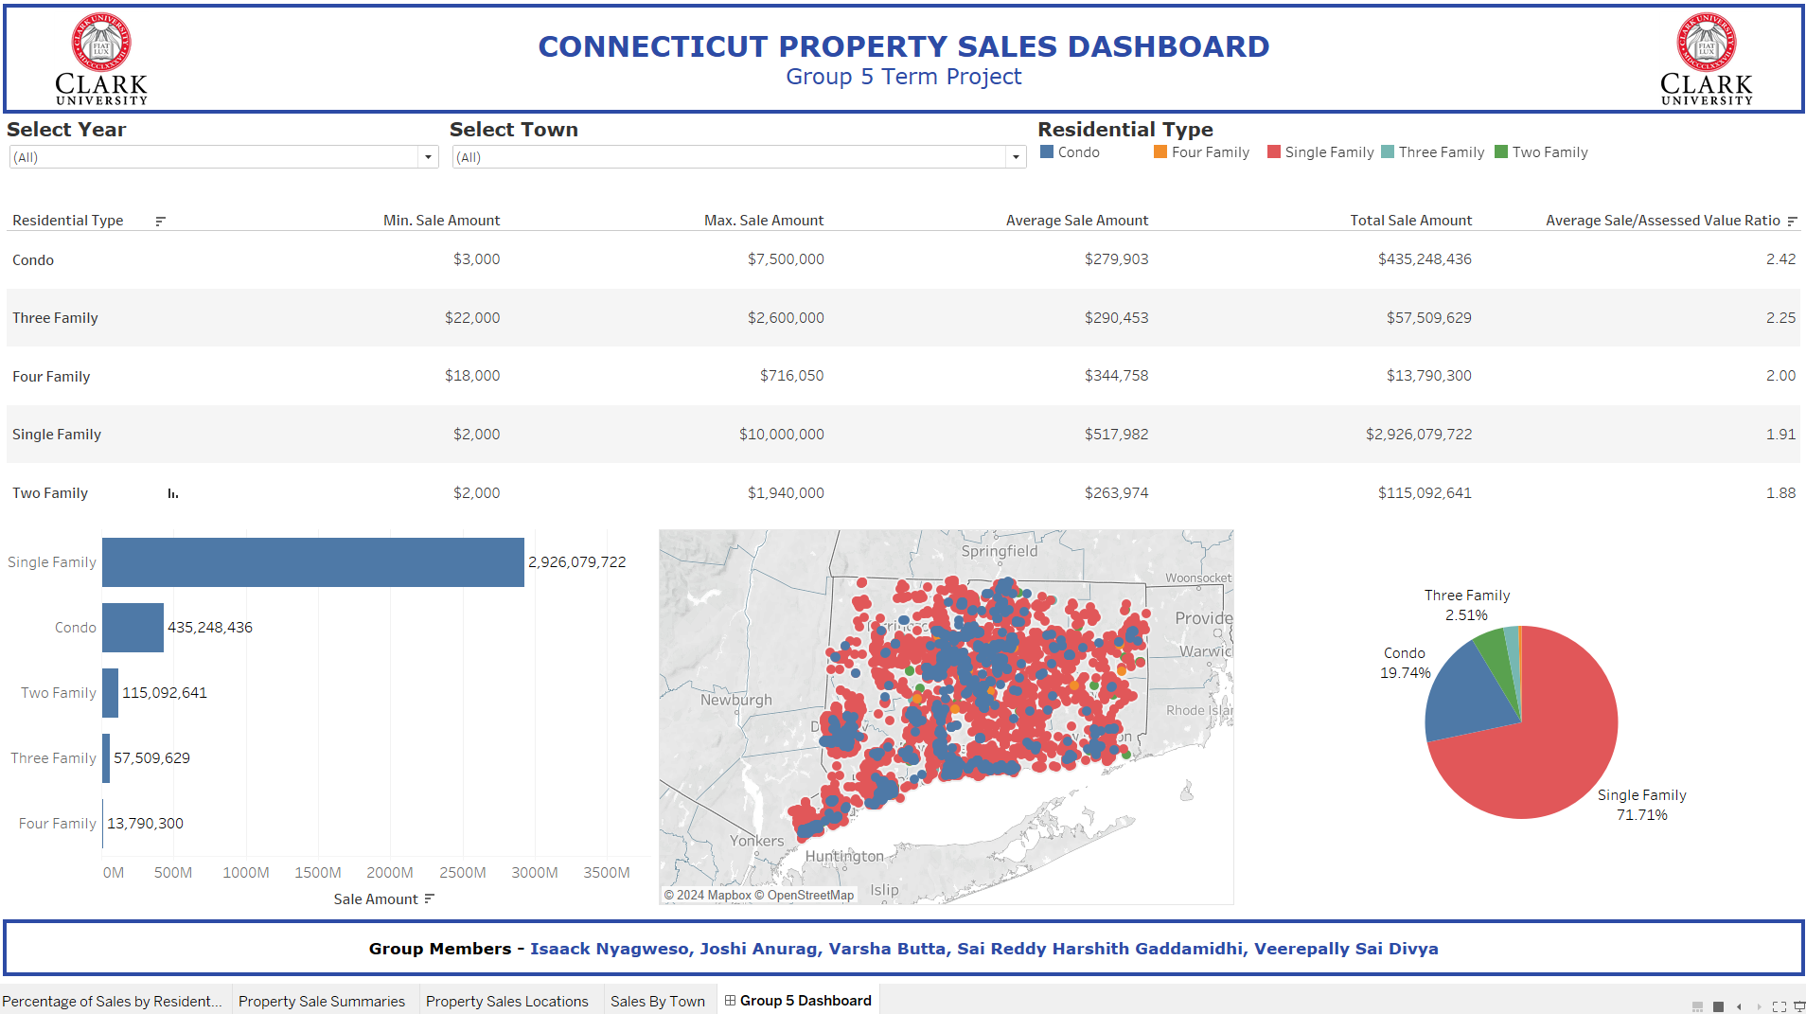
Figure 1: Property sale dashboard

Question 2 - Show examples of creating calculated fields
We created Sale_Assessed_Ratio calculated field formulated as the ratio of the property sale amount to assessed value. We use the average of this field aggregated by residential type (condo, single family, two family, three family and four family) in the dashboard table (see Figure 1).

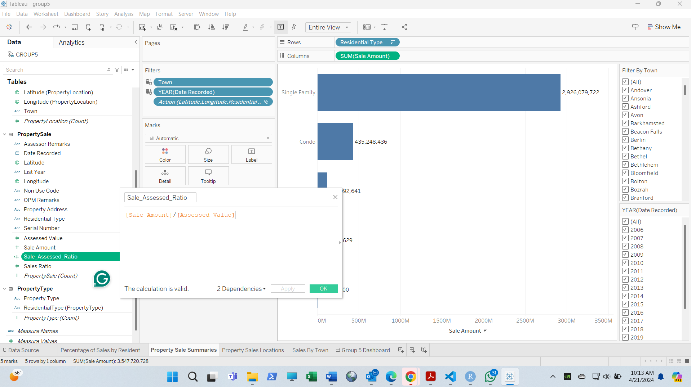
Figure 2: Creating of calculated field

Question 3 - Show examples of creating filters
We created dropdown filters for the Year and Town fields. These dropdowns enable users to filter dashboard data and graphs to filter property sales data by year and town. Users can select All in the dropdowns to show full data or select a specific year and town to show only data for that selection (see Figure 3, Figure 4 and Figure 5).
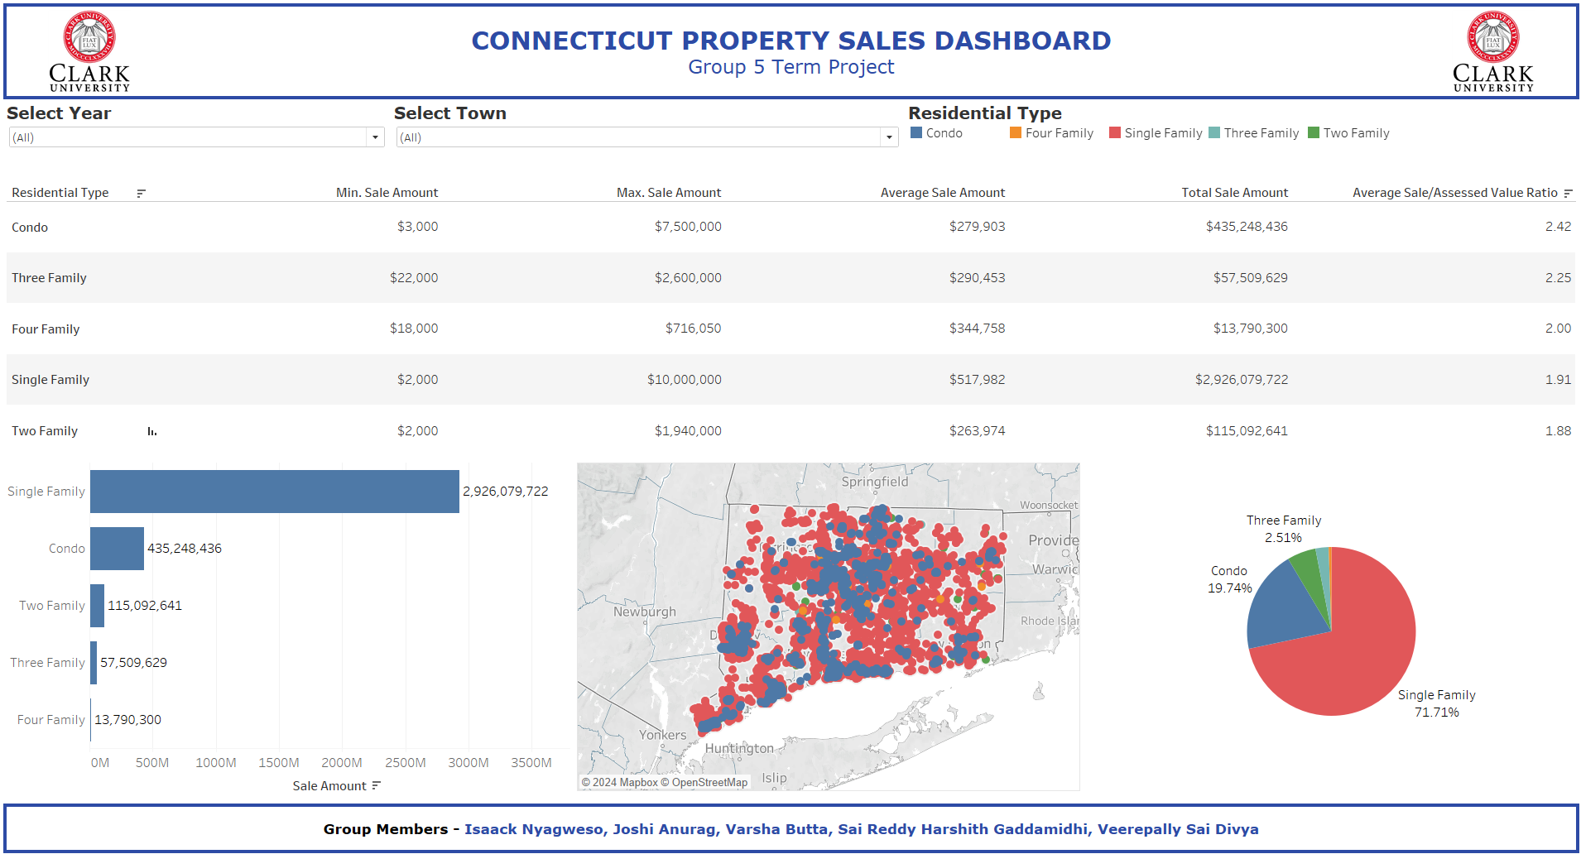
Figure 3: Default dashboard

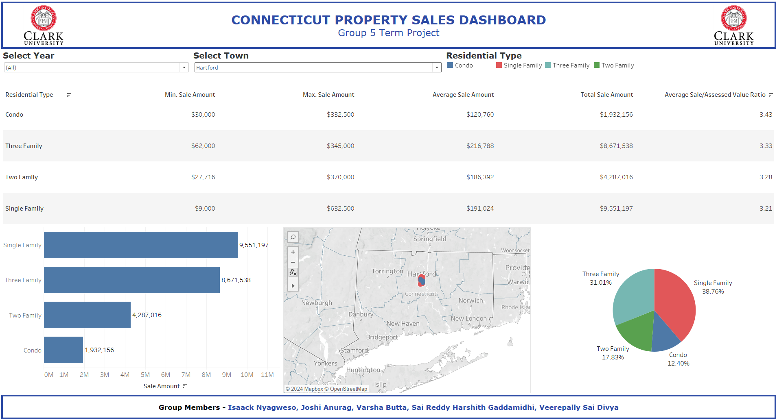
Figure 4: Dashboard filtered to show data for the selected town (Hartford)

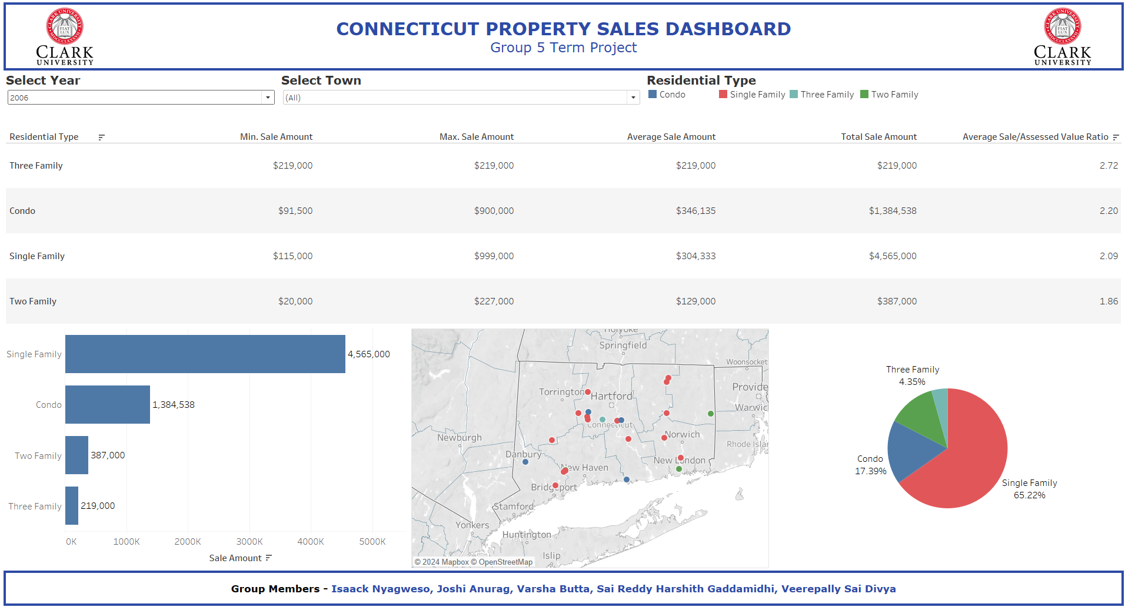
Figure 5: Dashboard filtered to show data for the selected year (2006)

Question 4 - Show examples of using filter actions based on selection on graph
We configured the map in the dashboard as a filter. Users can select property sale locations on the map using rectangular, radial or lasso selection. The property sale locations within the selection are highlighted in the map, and the dashboard graphs are updated with the selection sales statistics (see Figure 6 and Figure 7).
We also configured the dashboard legend for highlight filtering. Users can toggle Higlight Selected Item on the legend and select by Residential Type categories (condo, single-family, two-family, etc.) either in the legend or in the pie chart. The selected category is highlighted in all the dashboard graphics (see Figure 8, Figure 9 and Figure 10).
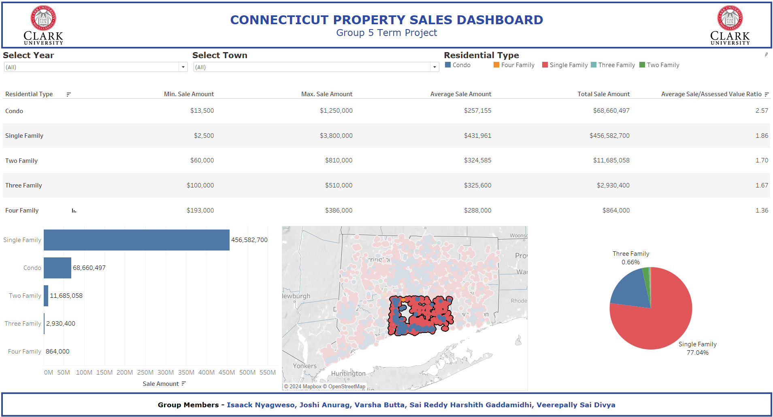
Figure 6: Using the map graph to filter property sale locations in South Connecticut

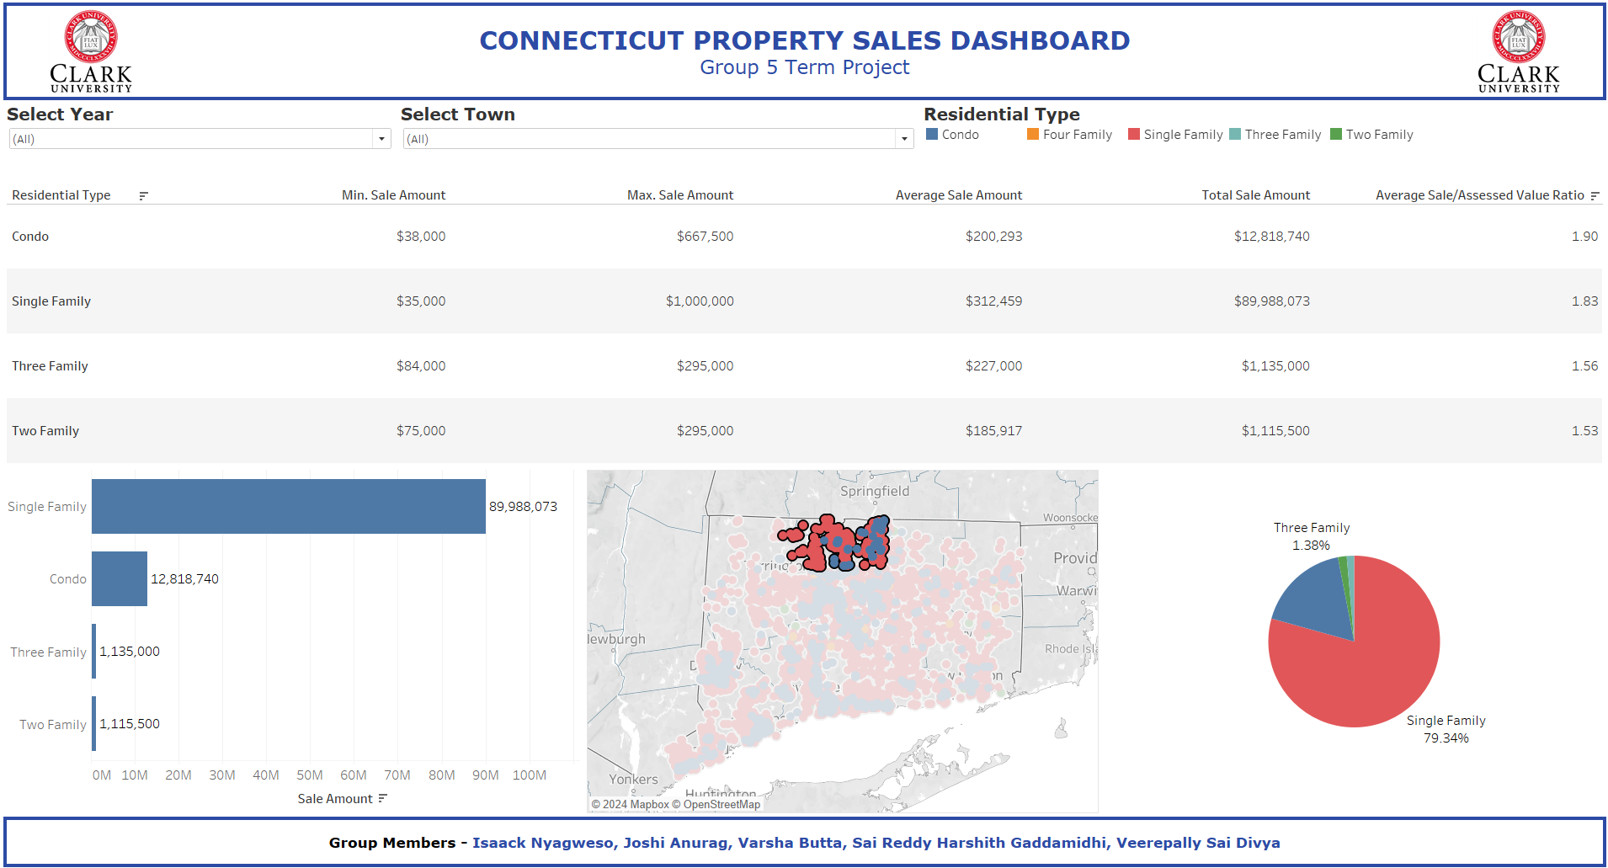
Figure 7: Using the map graph to filter property sale locations in North Connecticut

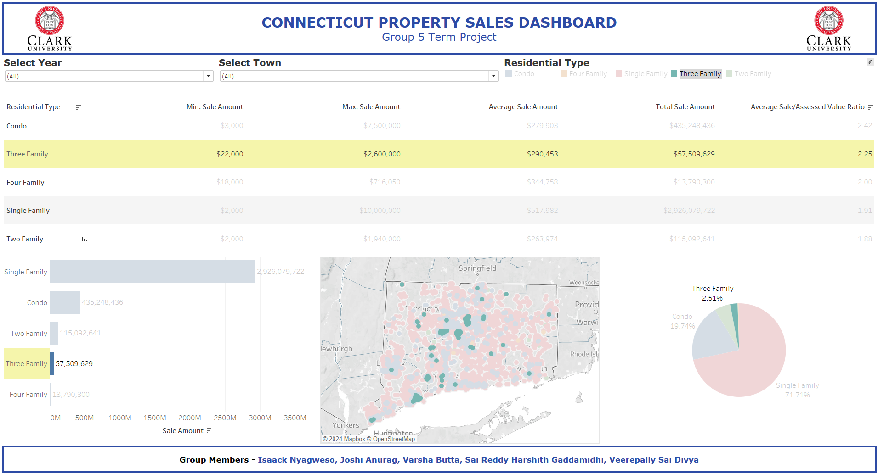
Figure 8: Using legend and pie chart to highlight two-family property sales

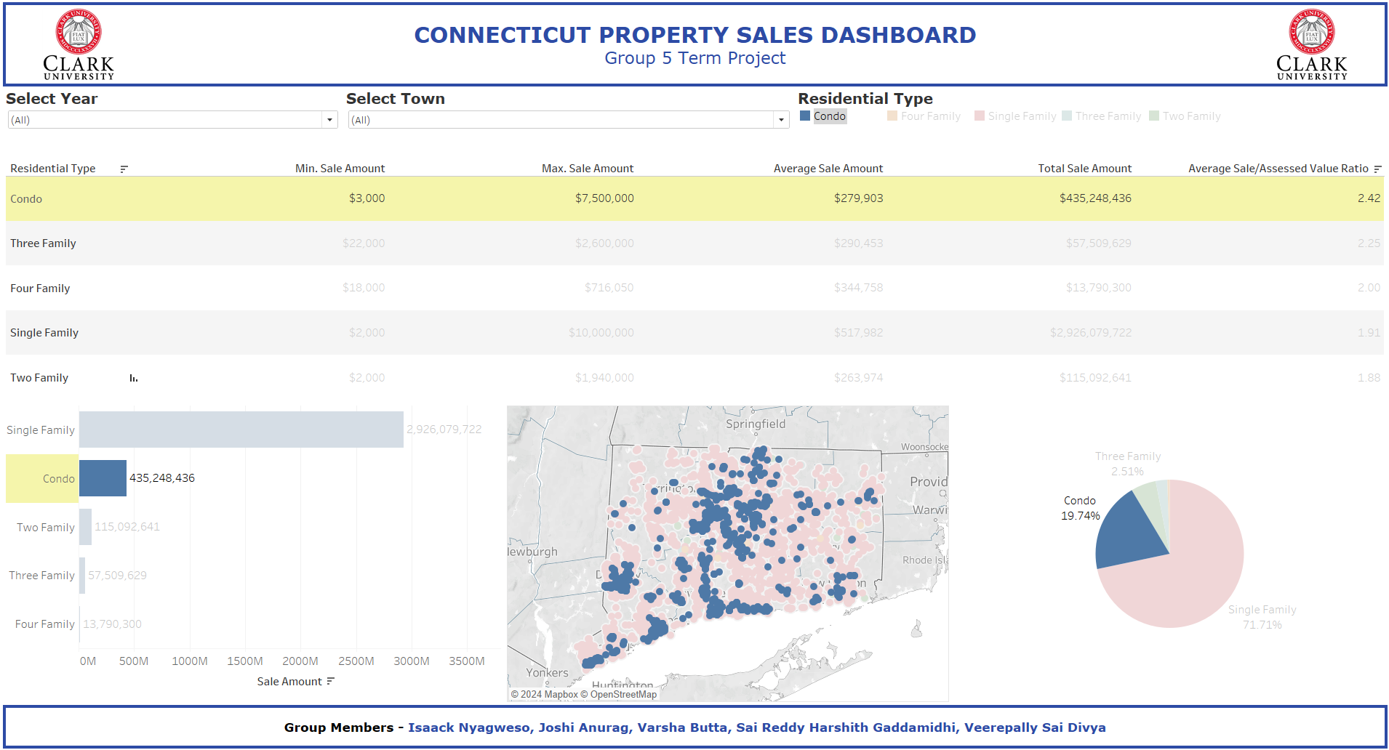
Figure 9: Using legend and pie chart to highlight condominium property sales

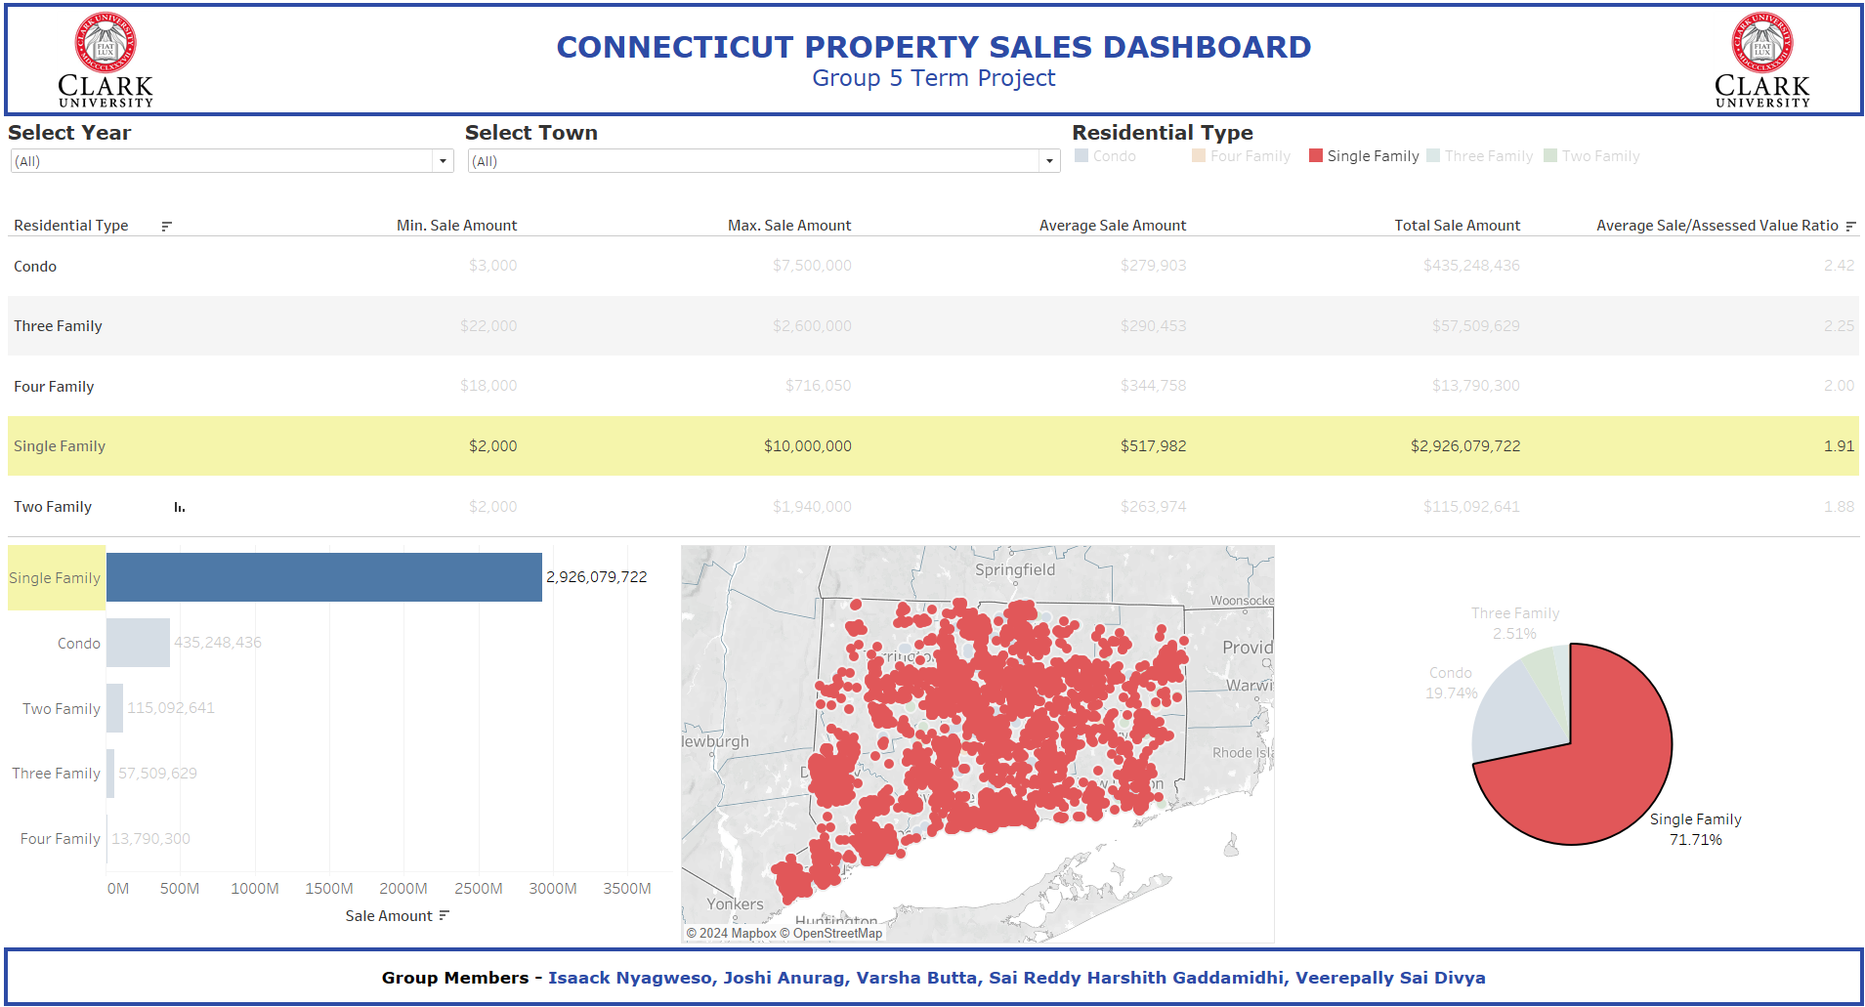
Figure 10: Using legend and pie chart to highlight single-family property sales

Question 5 - Show examples of using formatting
We formatted the dashboard table columns with financial data (Average sale amount, Min. sale amount, etc.) to show no decimals and to add US dollar currency ($) prefix to the amounts (see Figure 11).
We also formatted the calculated field values to show average percentage of sale amount to assessed value to two decimal places and to append percentage sign (%) (see Figure 12).

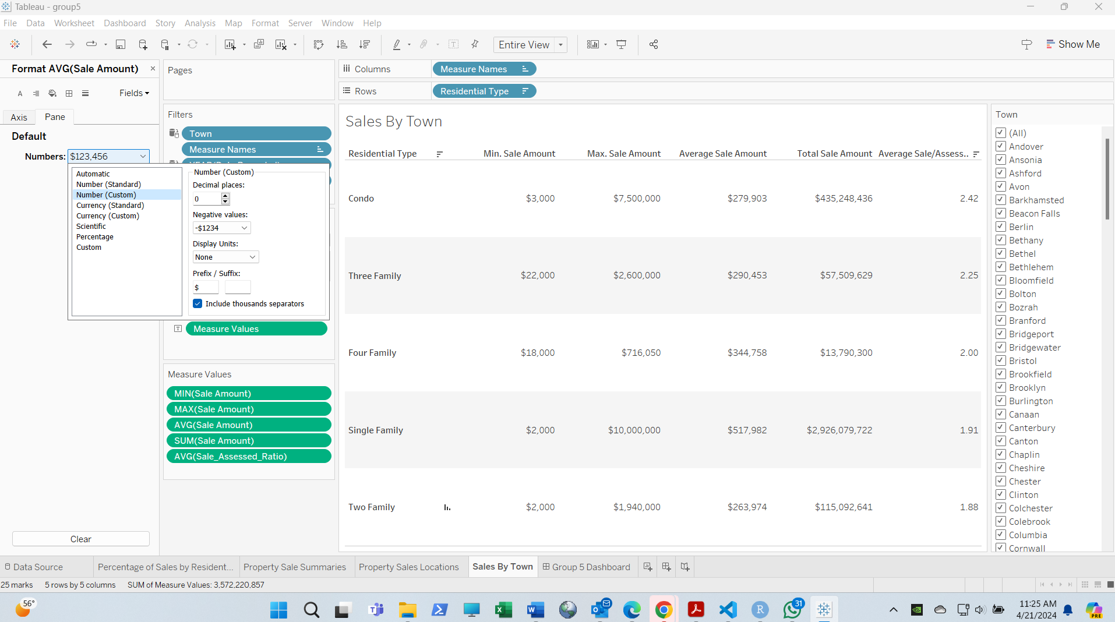
Figure 11: Formating financial columns with dollar symbol and no decimals

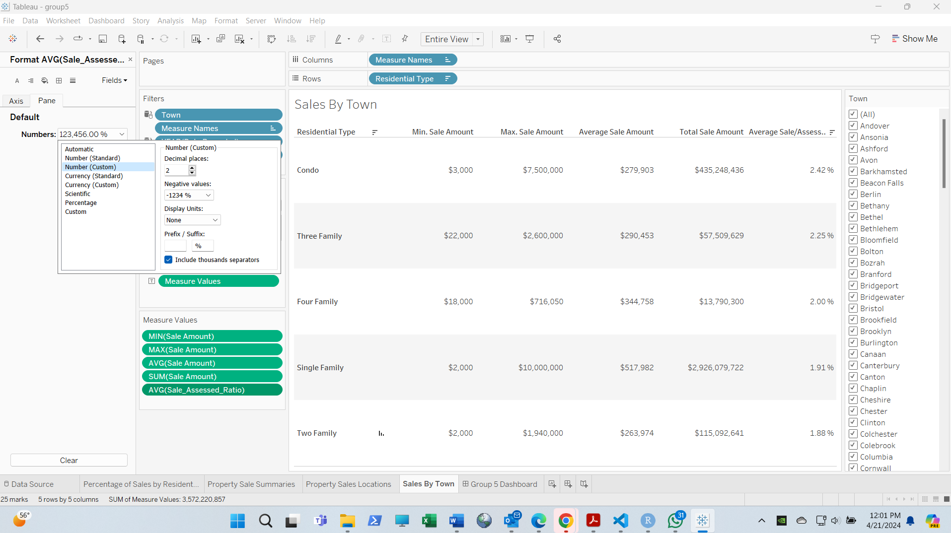
Figure 12: Formating the sale-assesed value ratio with 2 decimals and percent sign

